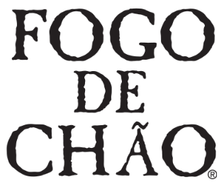

**PRESS KIT**

**SUPPORT OFFICE**

14850 Quorum Drive, Suite 500

Dallas, TX 75254

@fogorestaurants

 @fogo

 /fogo

 @fogodechao

[www.fogo.com](http://www.fogodechao.com)

**BRAND OVERVIEW**

* Fogo de Chão (fogo-dee-shown) is an internationally-renowned restaurant that allows guests to discover what’s next at every turn.
* Founded in Southern Brazil in 1979, Fogo elevates the centuries-old cooking technique of churrasco – the art of roasting high-quality cuts of meat over an open flame – into a cultural dining experience of discovery.

**MENU & CUISINE**

* Fogo is best known for its authentic full churrasco dining experience, as well as its Market Table and Feijoada Bar – which includes seasonal salads and soup, fresh vegetables, imported charcuterie and more.
* The Full Churrasco Experience features a variety of simply seasoned cuts of protein that are expertly butchered, fire-roasted and carved tableside by gaucho chefs.
* Guests can also indulge in dry-aged or premium cuts like Wagyu NY Strip, Tomahwak Ribeye or seafood options a la carte.
* Fogo offers an array of catering, takeout and delivery options, including large scale on-site grilling with gaucho service; individual, pre-cooked take-home meals; and ready-to-grill Fogo Experience bundles.
* In 2019, Fogo announced a collaboration with HerdX, an agri-tech and data company, to bring product transparency and traceability to guests.

**BAR FOGO**

* Bar Fogo is a casual alternative for guests looking to linger while enjoying smaller, sharable plates (like Braised Beef Rib Sliders and Brazilian Empanadas), Brazilian-inspired cocktails and an award-winning South American wine list.
* All-day happy hour and half priced bottles of South American wine under $100 are available every day in the dining room, bar and patio.

**LOCATIONS & GROWTH**

* Today, Fogo has nearly 70 locations across the globe, including locations in the United States, Brazil, Mexico and the Middle East.
* Fogo has announced a 15 percent planned annual growth rate through company-owned restaurants, with an additional international capital light franchise development strategy.

**COMMUNITY**

* Fogo is a long-standing partner of No Kid Hungry, the nonprofit dedicated to connecting children in need with healthy meals.

**LEADERSHIP TEAM**

**Barry McGowan**

Chief Executive Officer

**Tony Laday**

Chief Financial Officer

**Rick Lenderman**

Chief Operating Officer

**Janet Gieselman**

Chief Marketing Officer

**Selma Oliveira**

Chief Culture Officer

**Joseph Abbruzese**

Chief Development Officer

**Blake Bernet**

General Counsel

**Andy Feldmann**

President of International

**MEDIA CONTACT**

**Konnect Agency**

Samantha Sands

213.225.4414

[FogoPR@konnectagency.com](http://FogoPR@konnectagency.com)

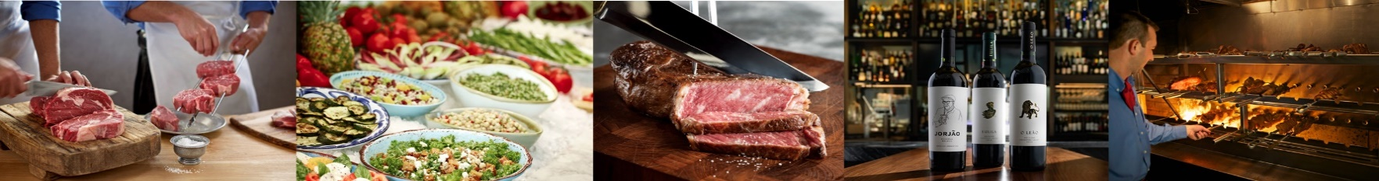

 ©2021 Fogo de Chão, Inc. All rights reserved.